Managing Anxiety
Breathing techniques:
Breathe in while counting for 5, and out while counting to 7. If this is not comfortable, you can change these numbers, as long as the second number is bigger than the first eg. 3/5
5/7

4 2 6
Breathe in for a count of 4, hold for a count of 2, breathe out for a count of 6

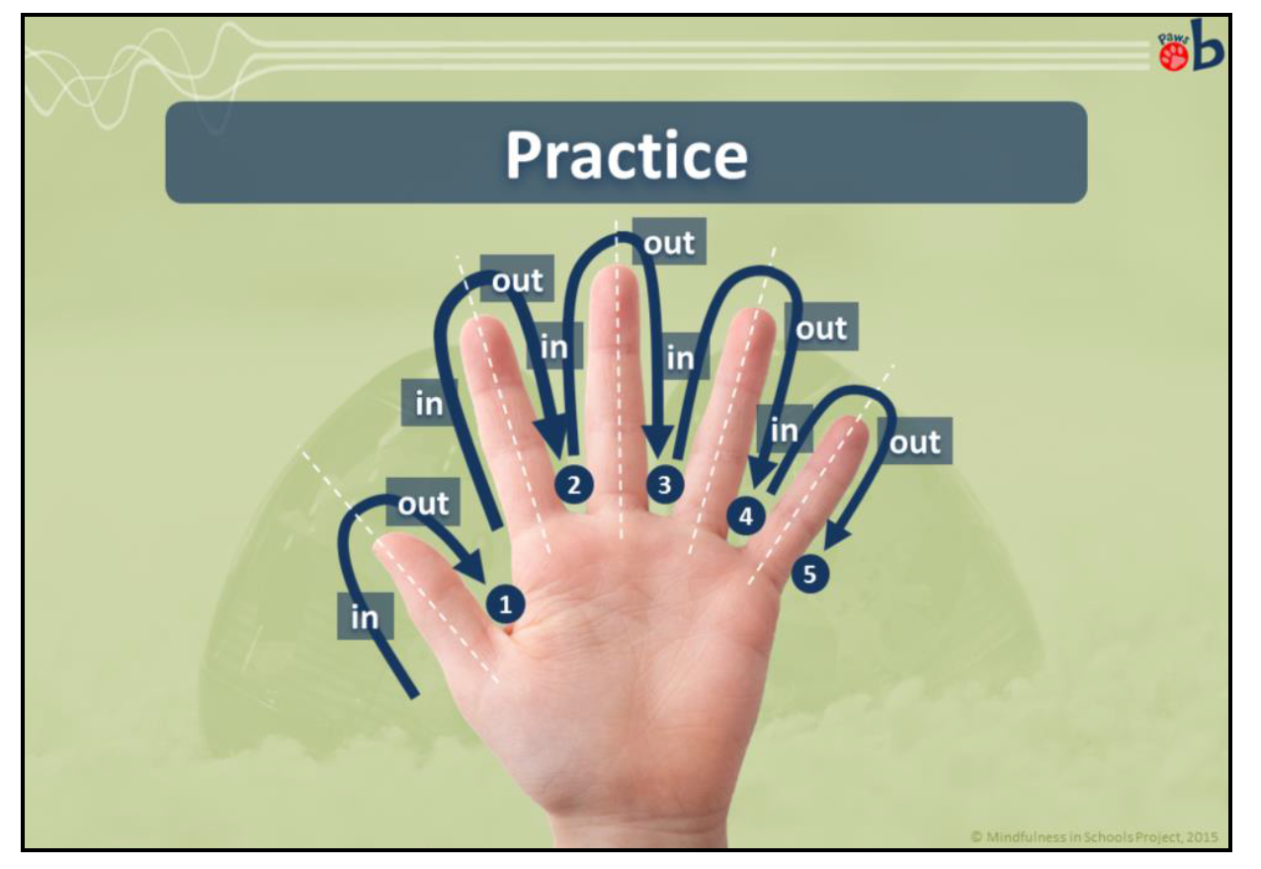

Trace your hand as you breathe, as seen in the picture.

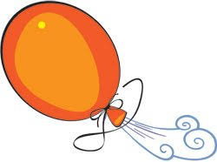
Breathe in, then breathe out steadily; imagine that you are blowing all worry and anger into the balloon. You can then let it go, or fasten it and kick it!

Progressive Muscle Relaxation:
Sit or lie in a comfortable position. As you breathe in, clench the muscles in each area of your body. Hold this for a moment, paying attention to how this feels. Then, as you breathe out, relax your muscles. Repeat this before moving on to the next area of your body.

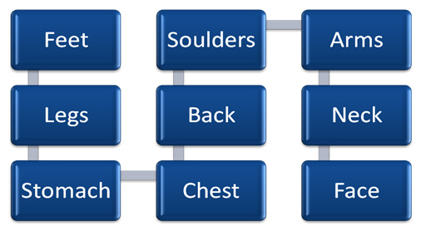

A guided PMR can be found on Youtube: https://www.youtube.com/watch?v=86HUcX8ZtAk

Visualisations:
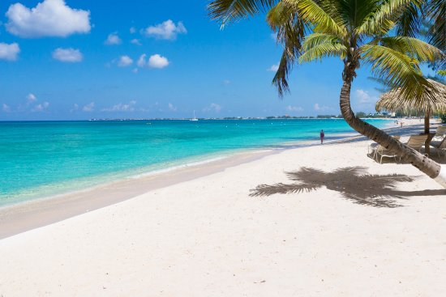
Guided visualisations encourage your body to relax while you imagine you are in a specific location. This one is a beach, but there are plenty more available:
https://www.youtube.com/watch?annotation_id=annotation_3961055845&feature=iv&src_vid=ar_W4jSzOlM&v=GZDjmofNQZg

Helpful Apps:

